STATE BOARD OF TECHNICAL EDUCATION AND TRAINING
ANDHRA PRADESH


WATER LEVEL INDICATOR

A project report submitted to the

State Board of Technical Education and Training, Andhrapradesh
In partial fulfillment for the award of the degree of

III YEAR - V SEMESTER, EE-511
DIPLOMA
in
ELECTRICAL AND ELECTRONICS ENGINEERING
BY
S.BALA ADHI NARAYANA (20351-EE-003)
- SK.BADEMIYA(20351-EE-002)

M.DINESH(20351-EE-009)
S.DINESH KUMAR(20351-EE-008)

Under the esteemed guidance of

Mr.S.RAVI KANTH, M.Tech

Assistant Professor
Department of EEE

2022-2023

CERTIFICATE


This is to certify that the project report entitled “WATER LEVEL INDICATOR” being submitted for the partial fulfilment of the requirements for the award of the degree in DIPLOMA in Electrical and Electronics Engineering from State Board of Technical Education and Training,Andhrapradesh is a bonafide work done by SK.BADEMIYA (20351-EE-002), S.BALA ADHI NARAYANA(20351-EE-003), S.DINESH KUMAR (20351-EE-008), M.DINESH (20351-EE-009) under my guidance during the academic year 2022-2023 and it has been found suitable for acceptance according to the requirement of the SBTET,Andhrapradesh.

Mr.S.RaviKanth, M.Tech Dr.G.Rajesh, Ph.D
Assistant Professor Professor
Project Guide Head of the Department

Examiner

ACKNOWLEDGEMENT

We would like to express my sincere gratitude to our guide, Mr.S.RAVI KANTH, Assistant Professor of EEE Department, DVR & Dr.HS MIC College of Technology, for his valuable guidance, inspiration, forbearance and keen interest in our project. He has been guiding us right through and rendered himself available whenever we required his attention and his valuable advice at every stage of this work. We are very much thankful to him for his coordination in this regard.

We have the immense pleasure in expressing our thanks and deep sense of gratitude to Dr. G.RAJESH, professor and Head of the Department of Polytechnic Education for extending necessary facilities for the completion of the project.

We wish our warm and grateful thanks to the staff of EEE department of DVR & Dr.HS MIC College of Technology for the assistance and their continuous encouragement in completing this project work successfully.

Finally, we would like to thank our families as they continued to supply the unconditional love and support which allowed us to complete this work.

DECLARATION

We carried out the project on “WATER LEVEL INDICATOR”, hereby declared that the matter included in this project is a genuine work done by us and has not been submitted either to this university or any other university/institute for the fulfillment of the requirement of the SBTET,Andhrapradesh.

PROJECT MEMBERS
SK.BADEMIYA(20351-EE-002)
S.BALA ADHI NARAYANA (20351-EE-003)
M.DINESH(20351-EE-009)
S.DINESH KUMAR(20351-EE-008)
ABSTRACT

Water tank overflow is a common problem which leads to the wastage of water. Though there are many solutions to it like ball valves which automatically stop the water flow once the tank gets full. But being electronics enthusiastic wouldn't you like an electronic solution for it? So here is a simple and handy DIY that will guide you to make a circuit which will detect the water level and will raise an alarm upon getting the water tank full or a preset level.

This simple transistor based water level indicator circuit is very useful to indicate the water levels in a tank. Whenever tank gets filled, we get alerts on particular levels. Here we have created 4 levels (low, medium, high and full), we can create alarms for more levels. We have added 3 LEDs to indicate initial three levels (A, B, C), and one Buzzer to indicate FULL level (D). When tanks gets filled completely we get beep sound from Buzzer.

S.NO | TITLE CHAPTERS
1. | INTRODUCTION
2. | COMPONENTS OVERVIEW
3. | DESCRIPTION
4. | BLOCK DIAGRAM
5. | CONSTRUCTION
6. | CIRCUIT DIAGRAM
7. | WORKING
8. | NEEDS OF WATER LEVEL INDICATOR
9. | APPLICATIONS
10. | ADVANTAGES
11. | DISADVANTAGES
12. | CONCLUSION

INTRODUCTION

A water level indicator is a system that relays information back to a control panel to indicate whether a body of water has a high or low water level. Some water level indicators use a combination of probe sensors or float switches to sense water levels.
A water level indicator is used to show the level of water in an over head tank, this keep the user informed about the water level at all the time and avoids the situation of water running out when it is most needed. Indicator circuit also has alarm feature. It not indicate amounts of water present in overhead tank but also gives an alarm when the tank is full.

Nowadays everybody has overhead tank at their homes, but the one who has a water tank above knows the kind of problems that they face. Water tank overflow is a common problem which leads to the wastage of water. Being electronics enthusiastic made a simple and handy circuit which will detect the water level and will raise an alarm upon getting the water tank full or a preset level.
This simple transistor based water level indicator circuit is very useful to indicate the water levels in a tank. Whenever tank gets filled, we get alerts on particular levels. Here we have created levels by alarms & we have added LEDs to indicate the level of water and one buzzer to indicate full level. When tanks gets filled completely we get beep sound from buzzer. So now we do not have to worry about overflow and water out anymore.

COMPONENT

S.NO | NAME OF THE MATERIALS | QUANTITY
1. | BC 547 TRANSISTORS | 04
2. | 220 OHMS RESISTORS | 03
3. | LEDS | 03
4. | BUZZER | 01
5. | 9V BATTERY | 01
6. | CONNECTING WIRES | AS  REQURIED

OVERVIEW OF COMPONENTS

- BC547 Transistor
When asking BC547 belongs to which type of the triode, basically, we think that BC547 is a normal NPN (Negative-Positive-Negative) junction transistor. And he bc547 parameter and the bc547 pin diagram are very important in the basic knowledge of BC547.
Below I will discuss the new electronic component called BC547. It is a BJT transistor and is often used to satisfy the need of quick switching. If you use this transistor in an engineering project, I want to suggest you to download BC547 Proteus Simulation. As we all know, simulating before entering the hardware is always a better strategy. So just let us to take a look at the basic knowledge of BC547.

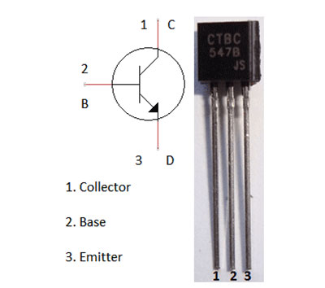

- BC547 is a bipolar junction transistor (BJT).
- It is kind of an NPN transistor.
- It has three terminals: Emitter, Collector and Base.
- The maximum current gain of BC547 is 800A.
- The Collector−Emitter Voltage is 65V.
- The Collector-Base Voltage is 80V.

- 220 ohms resistors
A resistor is a passive two-terminal electrical component that implements electrical resistance as a circuit element. Resistors act to reduce current flow, and, at the same time, act to lower voltage levels within circuits. In electronic circuits, resistors are used to limit current flow, to adjust signal levels, bias active elements, and terminate transmission lines among other uses.

Hence the colour code of 220 ohm resistor will be – red, red and brown.We are using the resistor to limit the current that the LED can use.

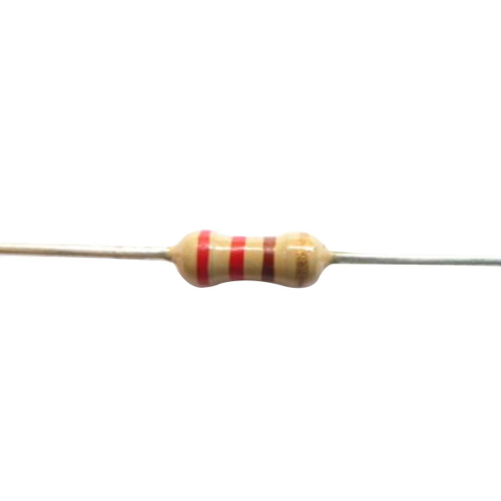

220 Ohms resistors Symbol:

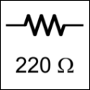

- LED's
A light-emitting diode (LED) is a semiconductor device that emits light when current flows through it. Electrons in the semiconductor recombine with electron holes, releasing energy in the form of photons. The color of the light (corresponding to the energy of the photons) is determined by the energy required for electrons to cross the band gap of the semiconductor.White light is obtained by using multiple semiconductors or a layer of light-emitting phosphor on the semiconductor device.
Light-emitting diode (LED) is a widely used standard source of light in electrical equipment. It has a wide range of applications ranging from your mobile phone to large advertising billboards. They mostly find applications in devices that show the time and display different types of data.

LED Symbol:
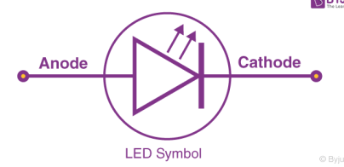
\

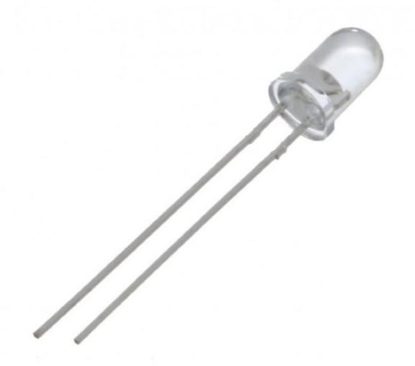

- Buzzer
A buzzer or beeper is an audio signaling device, which may be mechanical, electromechanical, or piezoelectric (piezo for short). Typical uses of buzzers and beepers include alarm devices, timers, train and confirmation of user input such as a mouse click or keystroke.
The electric buzzer was invented in 1831 by Joseph Henry. They were mainly used in early doorbells until they were phased out in the early 1930s in favor of musical chimes, which had a softer tone.

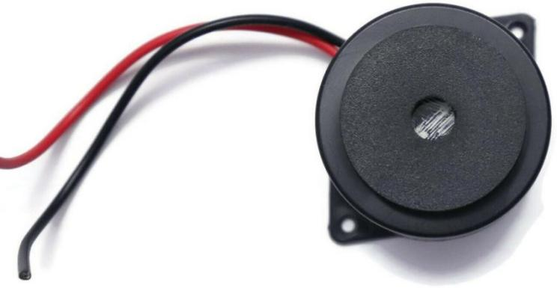

Buzzer symbol:

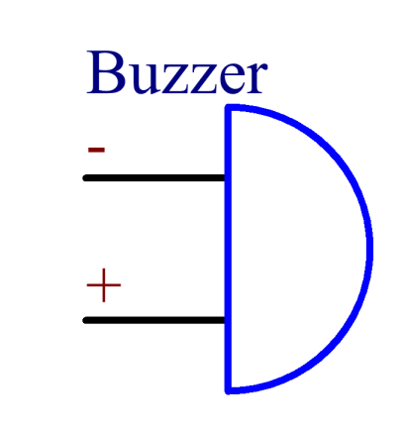

- Nine-volt battery
The nine-volt battery, or 9-volt battery, is an electric battery that supplies a nominal voltage of 9 volts. Actual voltage measures 7.2 to 9.6 volts, depending on battery chemistry. Batteries of various sizes and capacities are manufactured; a very common size is known as PP3, introduced for early transistor radios. The PP3 has a rectangular prism shape with rounded edges and two polarized snap connectors on the top. This type is commonly used for many applications including household uses such as smoke and gas detectors, clocks, and toys.

Rechargeable nine-volt batteries usually come in two options: these are NiMH and Lithium. Lithium batteries double the NiMH capacity. NiMH's 9V battery capacity last for about four hours with the rechargeable Lithium lasts for 7 to 7.5 hours.

All batteries have an expiration date mentioned on the packaging and on the cell itself. The battery may still work after that date, but with minor performance.

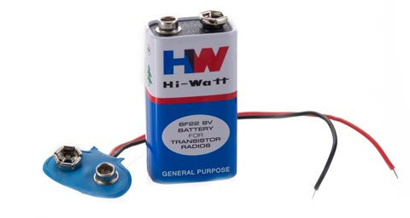
Nine-volt battery symbol:

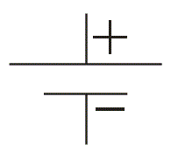
- Connecting wires

A connecting wire is represented by a straight line. It is usually made of copper and is provided with insulation to make electrical connections between two points
The three types of wires used in household circuits are Earth wire, Live wire, and Neutral wire.

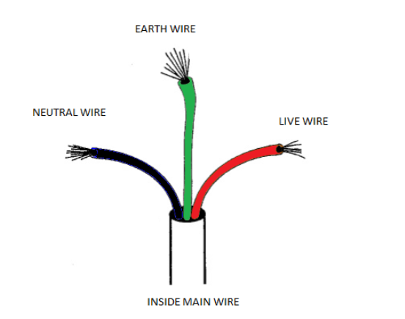

There are a few ways to connect two wires together. One way is to use a wire connector. You can also use a soldering iron to solder the wires together. Another way is to use a twist-on connector
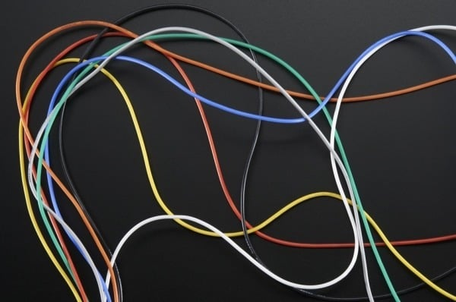

Connecting wires symbol:

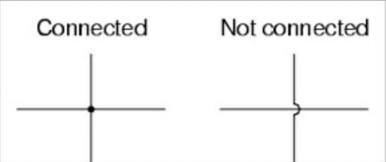

DESCRIPTION

Water tank overflow is a common problem which leads to the wastage of water. Though there are many solutions to it like ball valves which automatically stop the water flow once the tank gets full. But being an electronics enthusiastic wouldn’t you like an electronic solution for it? So here is a simple and handy DIY water alarm project tutorial that will guide you to make a circuit which will detect the water level and will raise an alarm upon getting the water tank full or a preset level.

This simple transistor based water level indicator circuit is very useful to indicate the water levels in a tank. Whenever tank gets filled, we get alerts on particular levels. Here we have created 4 levels (low, medium, high and full), we can create alarms for more levels. We have added 3 LEDs to indicate initial three levels (A, B, C), and one Buzzer to indicate FULL level (D). When tanks gets filled completely we get beep sound from Buzzer.
If you want to improve the project by adding a display and automatic motor on-off control then you can simply add a microcontroller like Arduino to sense the water changes and control the display and motor accordingly, if you want more details about that project you can check out the Arduino based water level indicator and controller project.
BLOCK DIAGRAM

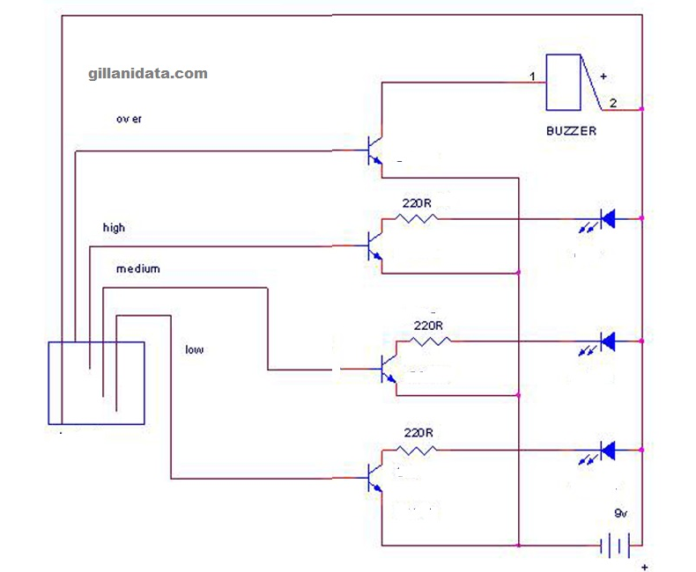

CONSTRUCTION

- Insert BC547 transistor on the breadboard. The left one is collector, the middle one is base and the last one is the emitter.
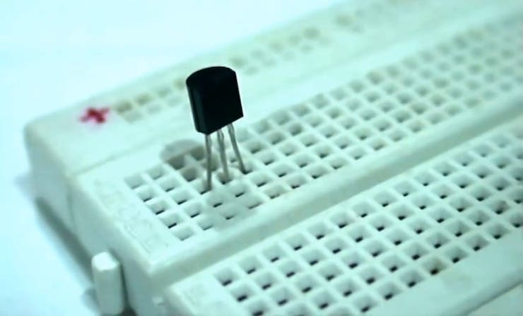
.

- . Insert the other two transistors as well on the breadboard
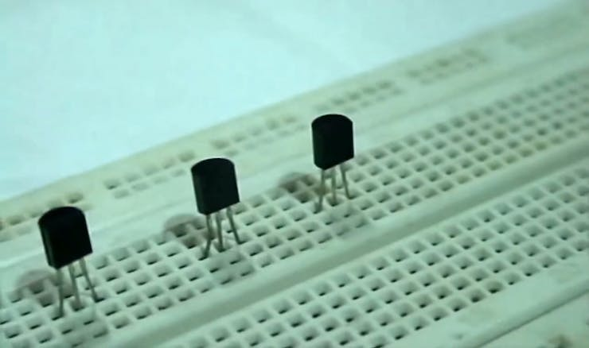
- Connect 220 ohms resistors to all the collector terminals of the transistor of the breadboard.
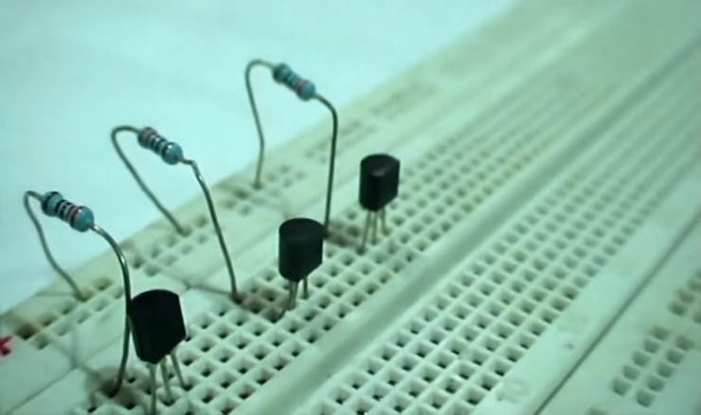

- Now insert the green Led with its anode to the emitter of first transistor and cathode to the negative rail of the breadboard and do the same for white and red LEDs.
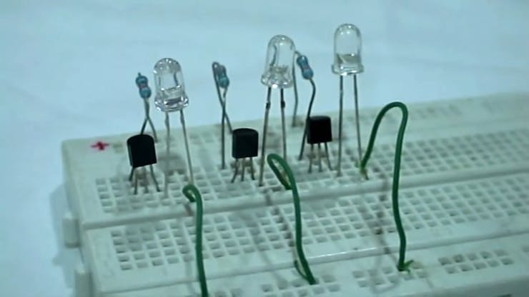
- Now connect the buzzer on the breadboard. Connect the negative wire of the buzzer to the negative rail of the breadboard and positive wire to the emitter of the third transistor.

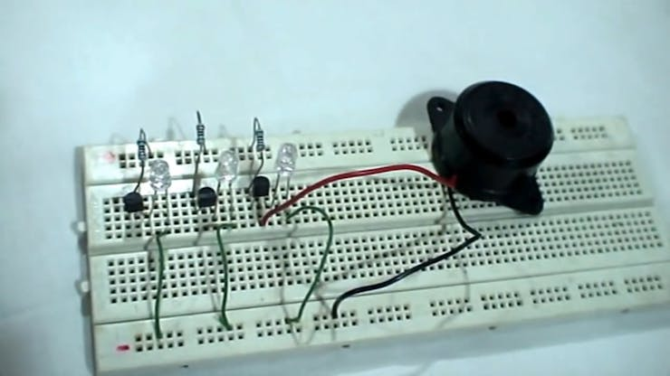
- . Connect one wire each to the base of the transistors. Dip the other end of the wire in the container with water, it is important to dip the wires in the water level-wise and not keep the bare ends of the wire on the same level.
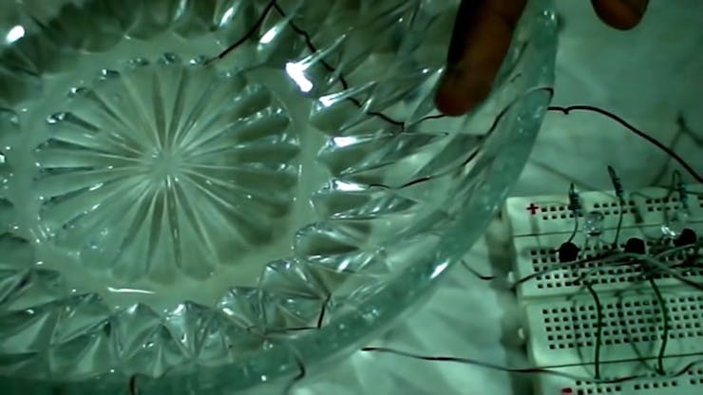

- Connect the power to the circuit and start adding water to the bowl and see the LED's light up sequentially and the buzzer buzzing at the end.

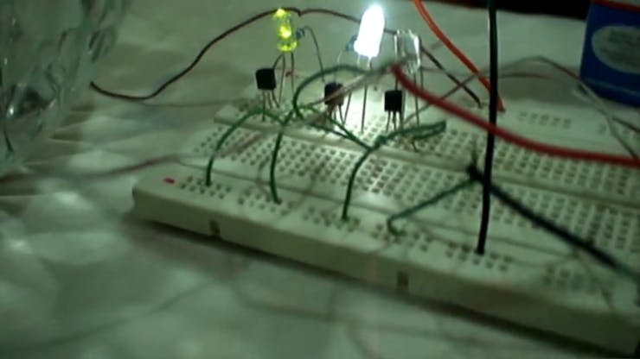

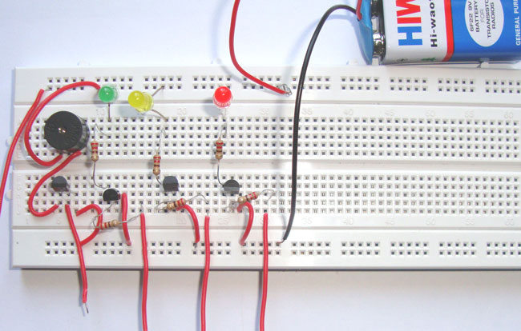

CIRCUIT DIAGRAM

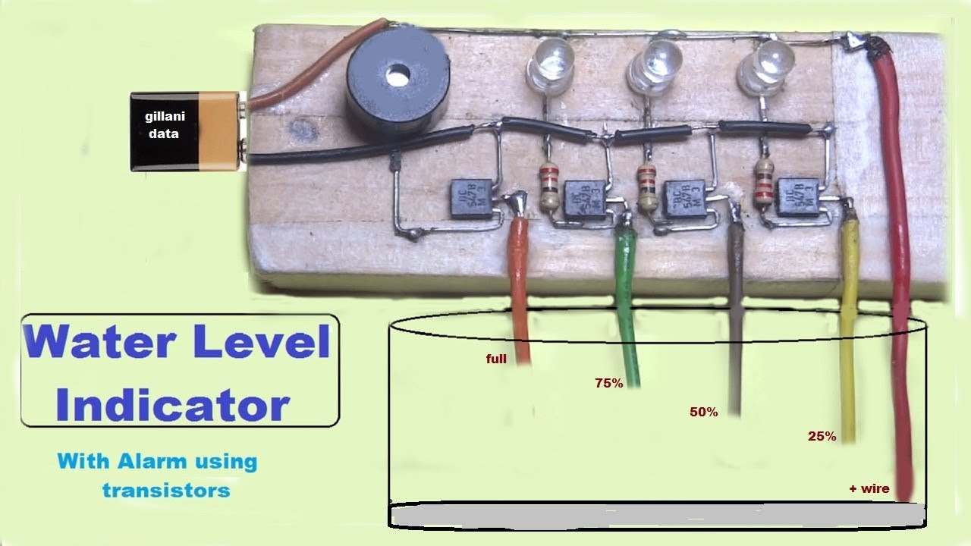
WORKING

- In this circuit, the BC547 is used as a switch. We have attached resistors of 220 Ohm at the base of transistors Q1, Q2 and Q3 to avoid the transistor from being destroyed by high current across the LED's. When no voltage is applied at the base of transistors, there is no current flowing through the collector and emitter terminal of the transistor. In result, LED will remain OFF.
- When the water level reaches point A, a conductive path is created between the base of transistor Q1 and the positive terminal of the battery. Therefore, the positive side of the battery and the base of the transistor Q1 gets connected with each other. As soon as the positive voltage is applied at the base of transistor Q1, the transistor Q1 is turned on and the RED LED starts glowing.
- Similar to the above process, a conductive path is formed between the base of transistor Q2 and the positive terminal of the battery, as soon as the water level reaches point B. A positive voltage is applied at the transistor which turns ON the yellow LED.
Contd…

- As the water level reaches to point C, the Transistor Q3 is turned ON due to the conductive path created and a positive voltage is applied at the base of it. This turns ON the white LED and the buzzer connected to the transistor Q3. This indicates that the container is full.
- BC 547 is known as cheap and easy to use transistor which can be used to design a low-cost water level indicator. You can use this device in day to day life to detect the various levels in water in a container.

COMPLETED CIRCUIT:
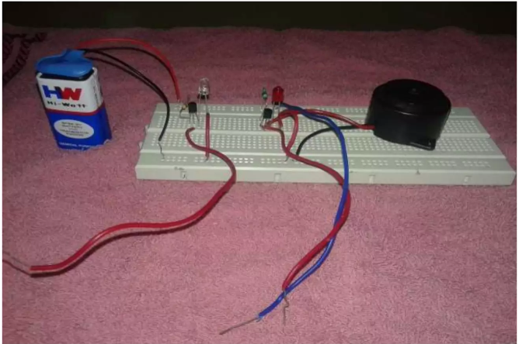
BEFORE WATER IS ADDED:
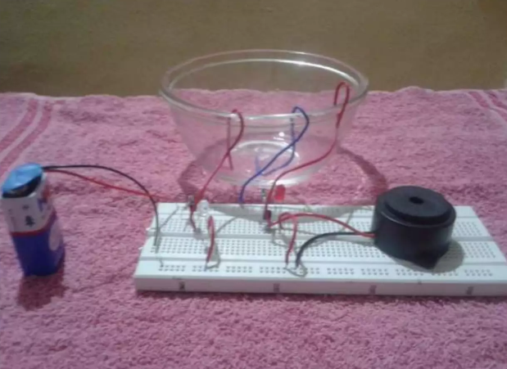
WHEN WATER IS ADDED(AT LOWEST LEVEL:
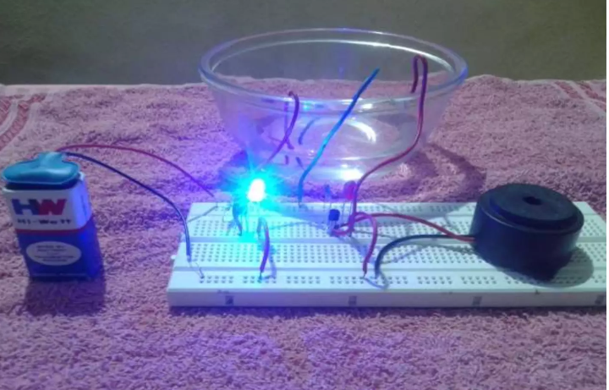
WHEN WATER IS FULL:
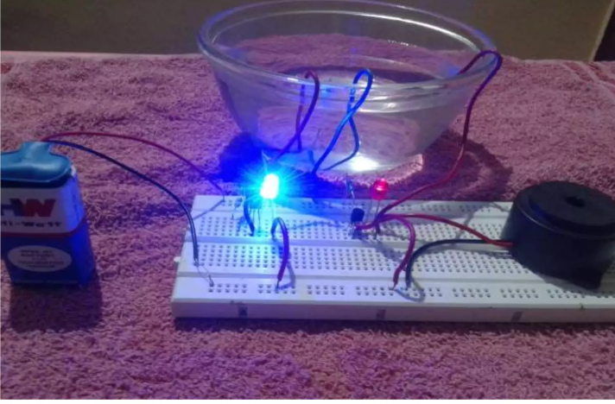

NEEDS OF WATER LEVEL INDICATOR

- To Overcome Overflow Problems.

- To Prevent Wastage Of Water.

- To Prevent Wastage Of Energy.

- Attention And Observation.

- For Sustainable Use Of Water And Judicious Use Of Electricity.

APPLICATIONS

- Hotels
- Home apartments
- Commercial complexes
- Factories
- Where cooling towers are used
- Anywhere, water levels need to be controlled
- In vehicles as a fuel level indicator
- In huge containers as a liquid level indicator
- Open wells
- Bore wells
- Sump Pumps
- Used to start and stop water pumps

ADVANTAGES

- Power Saver
- Money Saver
- Automatic
- Water Maximization
- Reliable Electronic Design
- Easily indicates when water level is full with a beep sound.
- Low maintenance.
- Compact and elegant design.
- Now no need to check the water level from the roof.
- Ensures no overflows or empty running of pump.
- Fully automatic, which does not require human power.
- Electricity consumed is very low.

DISADVANTAGES

- Water level controls need to be replaced every 3 years.
- The rust, foul and deteriorate
- Electronics are usually built seperately
- More difficult installation
- Most float switches are outdated
- No LED indicator lights
- No Warranty or Guarantee

CONCLUSION

With the help of this project we aim to save electricity as well as water. It is very important to save the natural resources. When the water in bucket /tank is reaches at a particular level we don’t realize that the tank is overflowing. This leads to more water as well as energy consumption. People too get engaged in that and stop doing other work until the tank is full which can cause a lot of unnecessary time consumption. So to overcome this situation this project can sense and indicate the water level in the tank when it reaches at a particular level and then the pump/tap turns on/off which will save water and electricity.. Its application is not only limited to house hold but can also be used in the industrial and agricultural sector.

